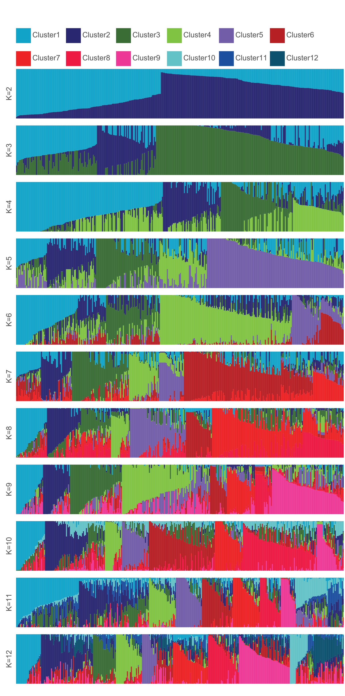
Figure S3. Plot of ancestry estimates inferred by ADMIXTURE for 329 worldwide barley accessions for 19,014 SNPs. Each colour represents a population, and the colour of individual haplotypes represents their proportional membership in the different populations. Membership coefficients for each population were merged across 100 replicate runs using the CLUMPP programme. The number of clusters (K) present in the entire population of 329 accessions was judged to be K = 7 based on the CV error. Shown are clusters 2 to 12.

